Allowing Others to EDIT your calendar (OUTLOOK)

Go To Calendar

Calendar Permissions

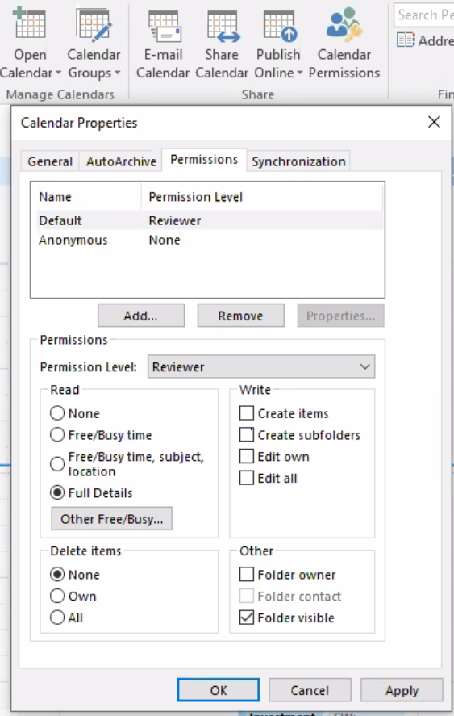

Add

Find their name

Hit Add ->

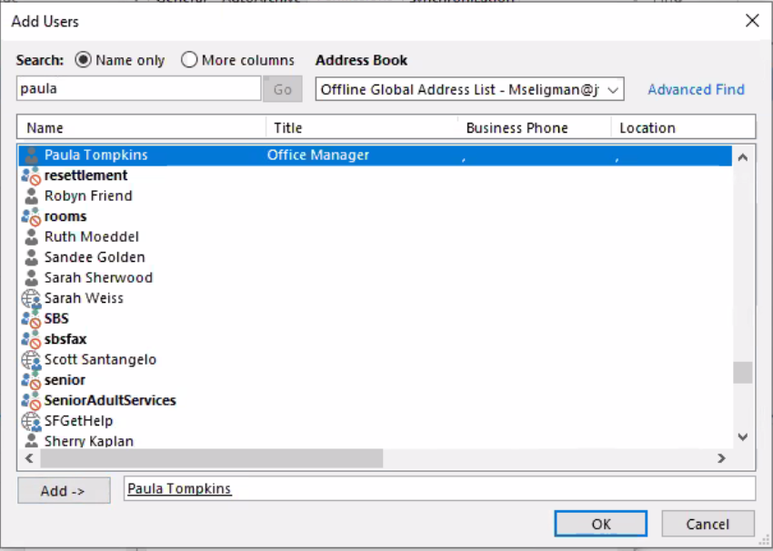
Hit OK

Click on the person’s name
Under Write: Set Edit All
Under Delete Items: Set All
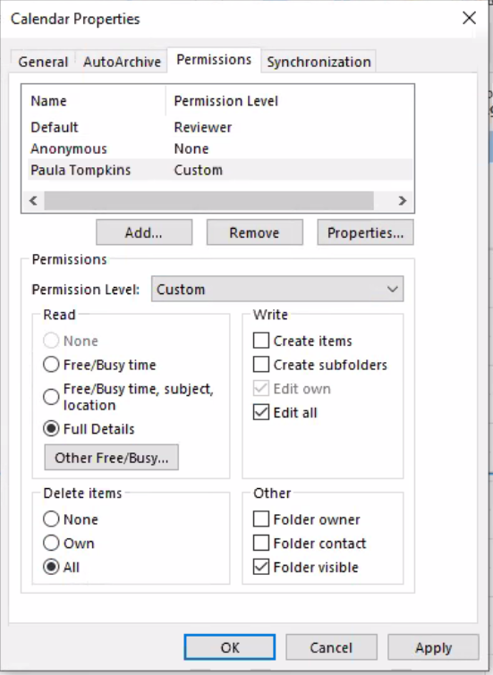

Hit OK

Allowing Others to EDIT your calendar (OFFICE.COM)

Go To Calendar

Click Share in the top right corner


Type in the Person’s Name you want to be able to manage your calendar
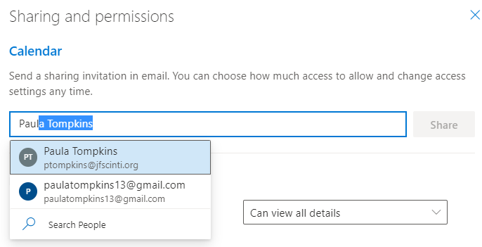

Select Can Edit and then Select Share


Click the X in the top corner to close the box.

